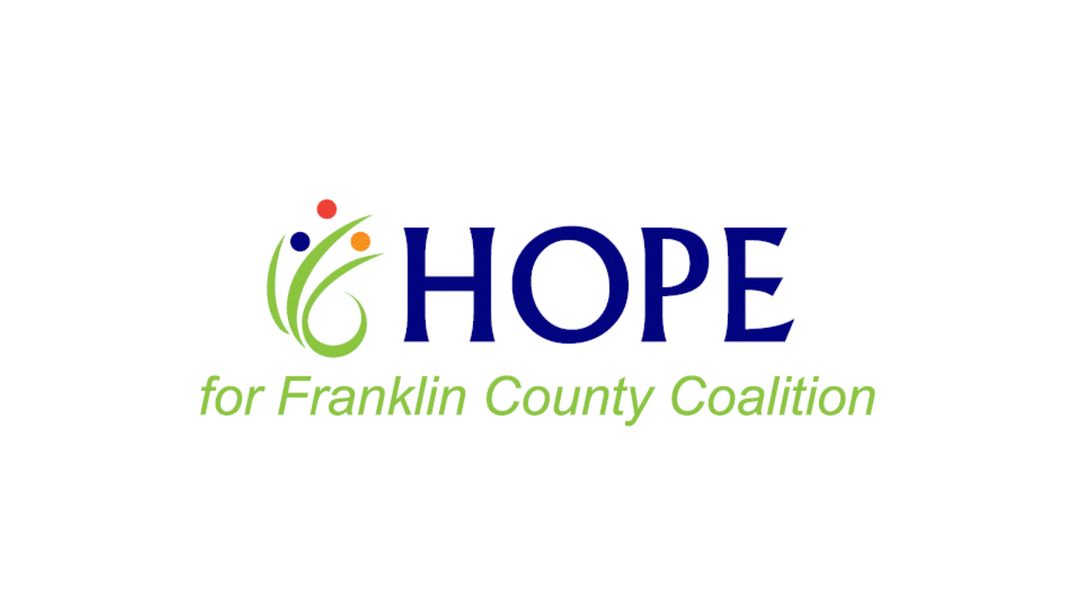

Mission: Empowering youth to make positive decisions and lead healthy, drug-free lives.

Project Update Meeting Agenda
9/21/22

- Welcome

- DFC UPDATE

- Recent Activities- A brief recap of all the stuff that’s happened since last time

  - Youth Coalition – Planning Session 8/20
  - Union Rotary Presentation- 8/31
  - Career/Volunteer Fair – 9/13
  - 100 Miles to Redemption Film- 9/15
  - YOUth Belong! Education/Distribution of Items
  - MAAG SUD Awareness Day – 9/17

- Upcoming Events- Activities that are coming up where we need help

  - Twist of Hope Field Day – 10/8, Union City Park, 1pm-6pm – Need HOPE Coalition Reps to hand out items, share about our coalition, and connect with the community
  - Youth Coalition – Free Fall Fun Event- 10/16, Foundations Parking Lot, 10am-2pm. Need help promoting to all families in the community
  - FC CRUSH Teen Drug Summit, 10/19, First Christian Church, Washington, 8am-2pm. Need HOPE Coalition Reps to hand out info to students and their adult sponsors

- Holiday Party

- Other Community Needs

  - Library Rx Safe Use & Disposal Project – Community Support Funds Request
  - Possible Transitional Shelter
  - Free Little Food Pantries

Next Meeting— October 19th-Ideas for a presentation?

